STRUCTURED QUERY LANGUAGE

1.SQL Basic:
1.1. what is SQL
SQL (Structured Query Language) is the standard language used to:
- Create and manage database structures (tables, views, etc.)
- Insert, update, delete, and retrieve data
- Control access to data
1.2 Oracle Data Types
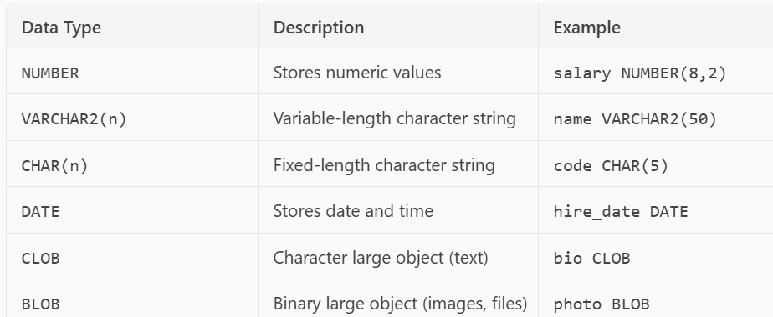

1.3 SQL Syntax Rules
- SQL is not case-sensitive (but strings are).
- Statements end with a semicolon (;).
- Use single quotes for string values: 'Sales'
- Use -- for single-line comments and /* ... */ for multi-line.
2. Data Definition Language (DDL)
- What is DDL?
DDL (Data Definition Language) is used to define and manage database structures like tables, views, indexes, etc.
- Common DDL Commands:
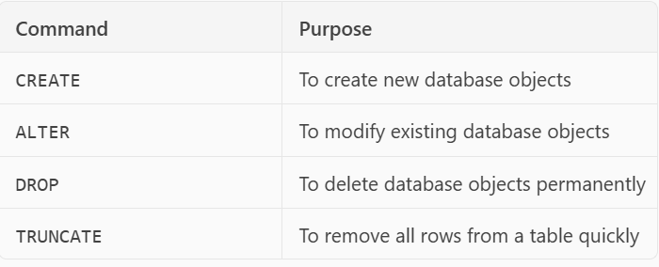

2.1 CREATE TABLE – Create a new table
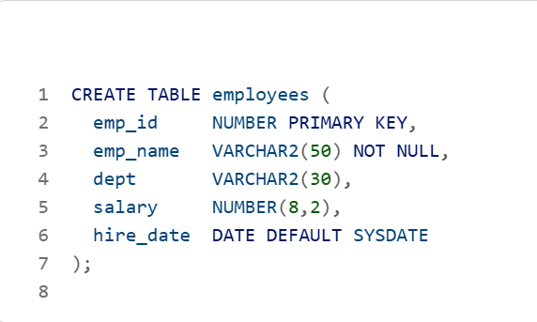
2.2 ALTER TABLE – Modify a table
- Add a new column:
- Modify a column:
- Drop a column:
2.3 DROP TABLE – Delete a table permanently
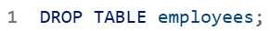
2.4 TRUNCATE TABLE – Delete all rows (faster than DELETE)
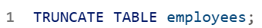
3. Constraints in Oracle SQL
- What are Constraints?
Constraints are rules applied to table columns to enforce data integrity. They ensure that the data entered into the table is valid, consistent, and reliable.
- Types of Constraints
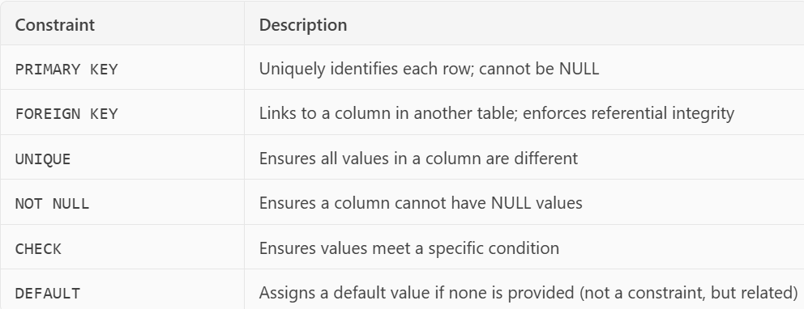
3.1 PRIMARY KEY
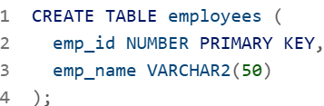
3.2 FOREIGN KEY
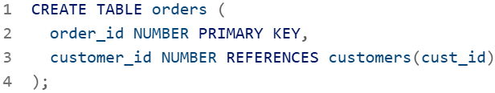
3.3 UNIQUE
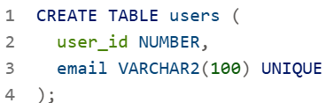
3.4 NOT NULL
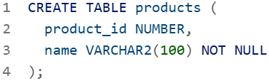
3.5 CHECK
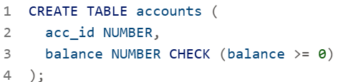

4. Data Manipulation Language (DML)
- What is DML?
DML is used to manipulate data stored in tables. It includes commands to:
- Insert new data
- Update existing data
- Delete data
- Merge data (insert or update based on conditions)
4.1 INSERT – Add new rows
4.2 UPDATE – Modify existing rows
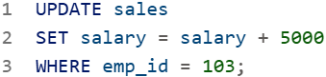
4.3 DELETE – Remove rows
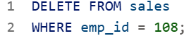
4.4 MERGE – Insert or update based on condition (Advanced DML)
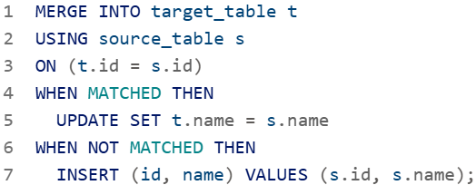

5. Data Query Language (DQL)
- What is DQL?
DQL is used to query data from tables using the SELECT statement. It includes filtering, sorting, formatting, and more.
- Topics in DQL:
- SELECT – Retrieve data
- WHERE – Filter rows
- ORDER BY – Sort results
- DISTINCT – Remove duplicates
- AS – Rename columns (aliasing)
5.1 SELECT – Basic Query
5.2 WHERE – Filter Rows
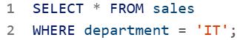
- OPERATOR
- Comparison Operators
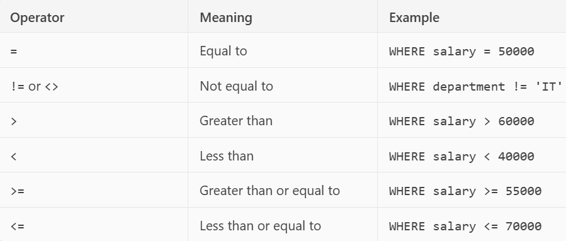

- Logical Operators
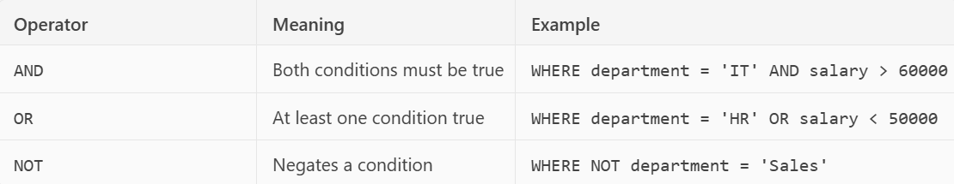
- Range Operator: BETWEE
- Set Operator: IN
- Pattern Matching: LIKE
- Null Check: IS NULL / IS NOT NULL

5.3 ORDER BY – Sort Results
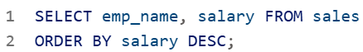
5.4 DISTINCT – Remove Duplicates
5.5 AS – Column Aliases

6. Functions in Oracle SQL
Functions are built-in tools that help you transform, format, and analyze data in your queries. They are categorized into:
- 6.1 String Functions
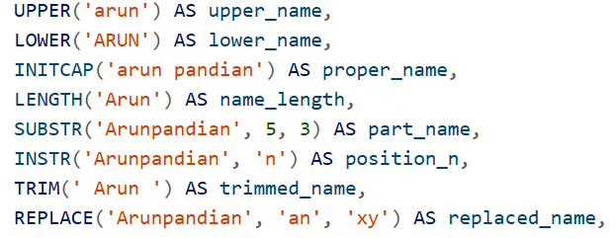
6.2 Number Functions
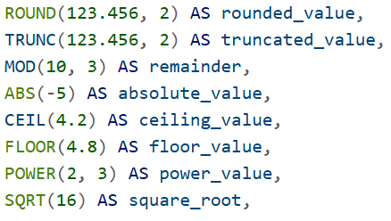
6.3 Date Functions
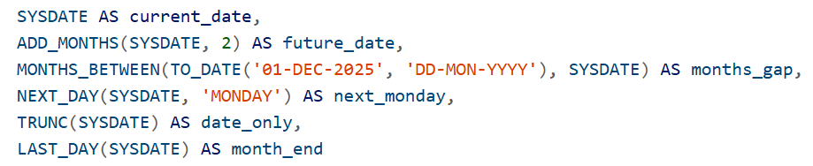
7. Joins in Oracle SQL
- What is a Join?
A join is used to combine rows from two or more tables based on a related column between them — usually a foreign key.
- Types of Joins:
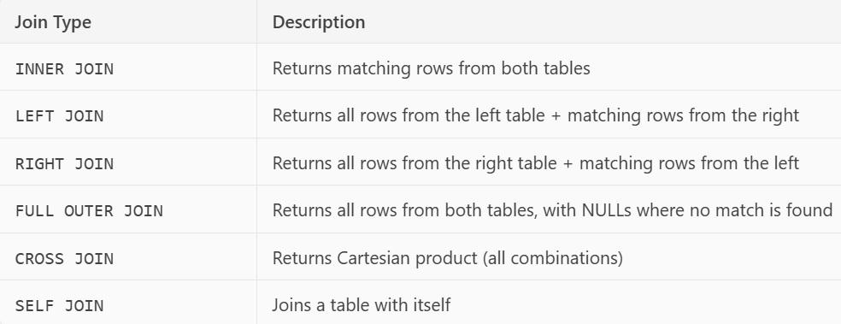
Example Tables
employees Table
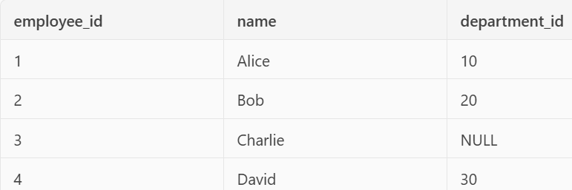
departments Table
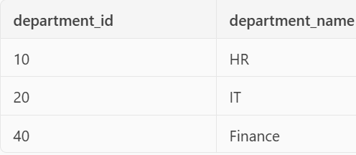
7.1 INNER JOIN
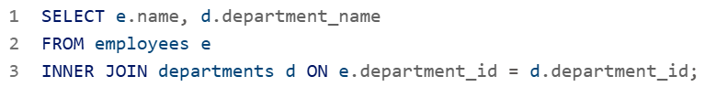
Result:
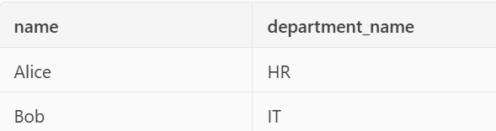
7.2 LEFT JOIN
Result:
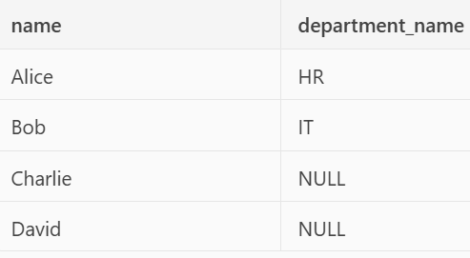
7.3 RIGHT JOIN
Result:
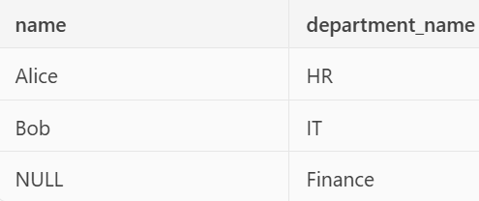
7.4 FULL OUTER JOIN
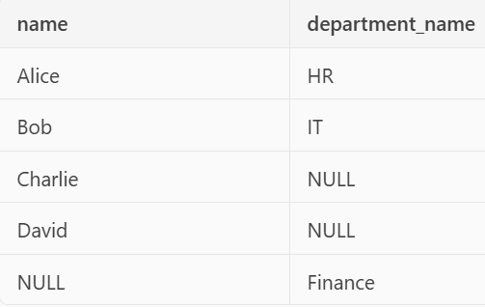
7.5 CROSS JOIN
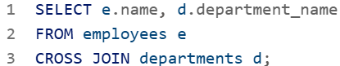
Result:
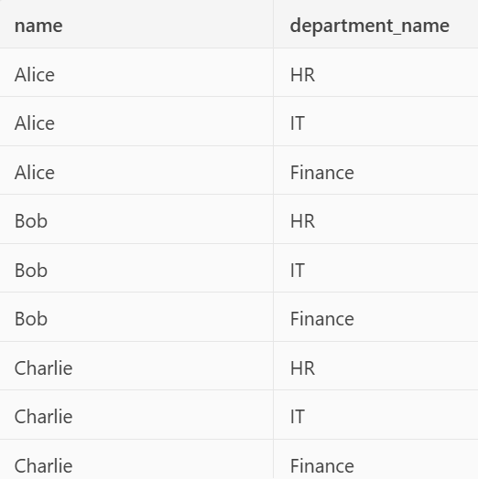

7.6 Self Join
Example Table: employees
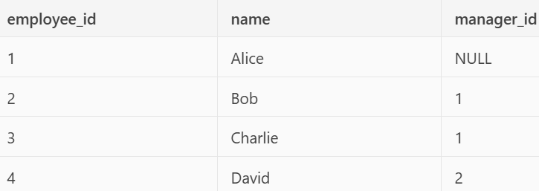
Result:
